**EXP NO 24. CREATE A STORAGE SERVICE USING ANY PUBLIC CLOUD SERVICE PROVIDER (AZURE/GCP/AWS) AND CHECK THE PUBLIC ACCESSIBILITY OF THE STORED FILE TO DEMONSTRATE STORAGE AS A SERVICE.**

**AIM:**

To demonstrate infrastructure as a service(iaas) by creating a virtual machine using a public cloud

service provider(azure/gcp/aws) configure with minimum cpu,ram and storage and launch the vm

image.

**PROCEDURE:**

STEP1: CREATE AN ACCOUNT IN MICROSOFT AZURE.

STEP2: GOTO RESOURCE GROUP AND CREATE A RESOURCE GROUP.

STEP3: GIVE NECESSARY THINGS FOR RESOURCE GROUP.

STEP4: CREATE A VIRTUAL NETWORK FOR TO CREATE A VIRTUAL MACHINE.

STEP5: NOW CREATE A VIRTUAL MACHINE WITH UR IP ADDRESS AN USERNAME AND

PASSWORD FOR YOUR VIRTUAL MACINE.

STEP6: AND YOUR VIRTUAL MACHINE IS DEPLOYED.

STEP7: NOW CONNECT THE VIRTUAL MACHINE AND DOWNLOAD THE RDP FILE TO OPEN YOUR

WINDOWS VIRTUAL MACHINE.

STEP8: CREATED A NEW WINDOWS VIRTUAL MACHINE

**IMPLEMENTATION:**

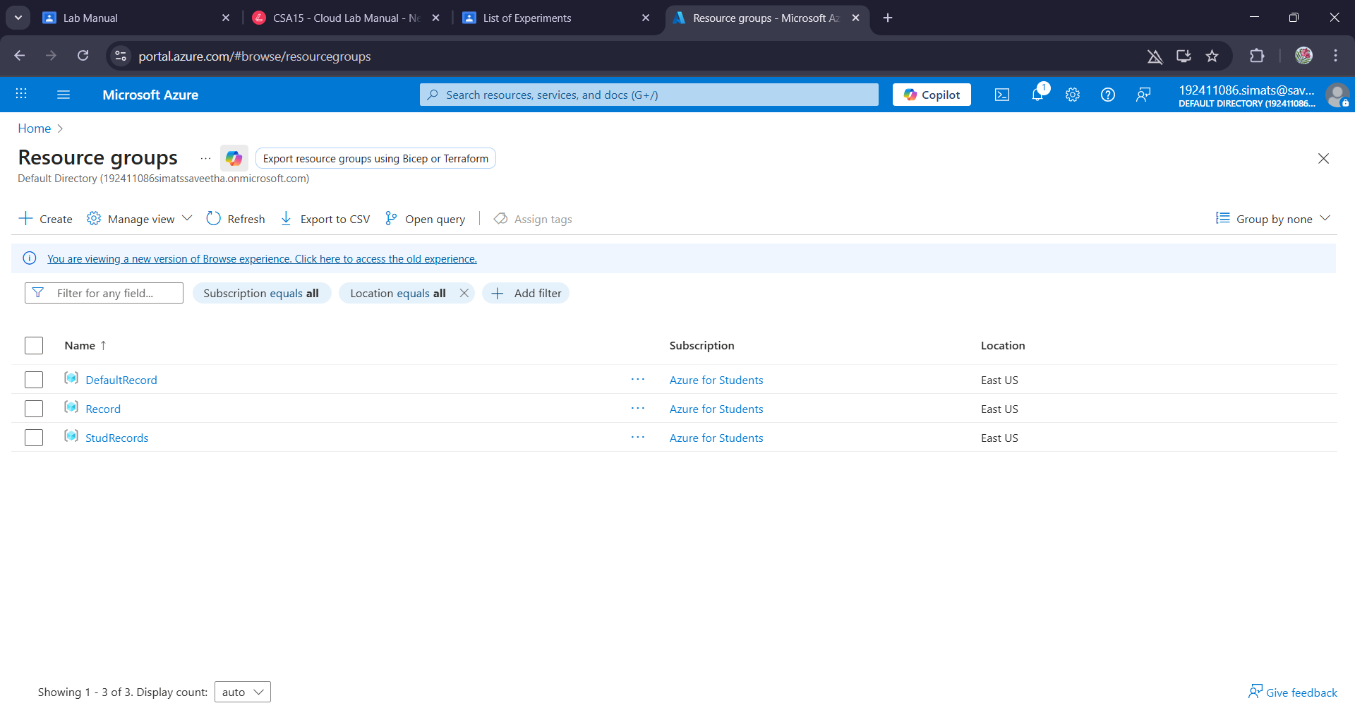

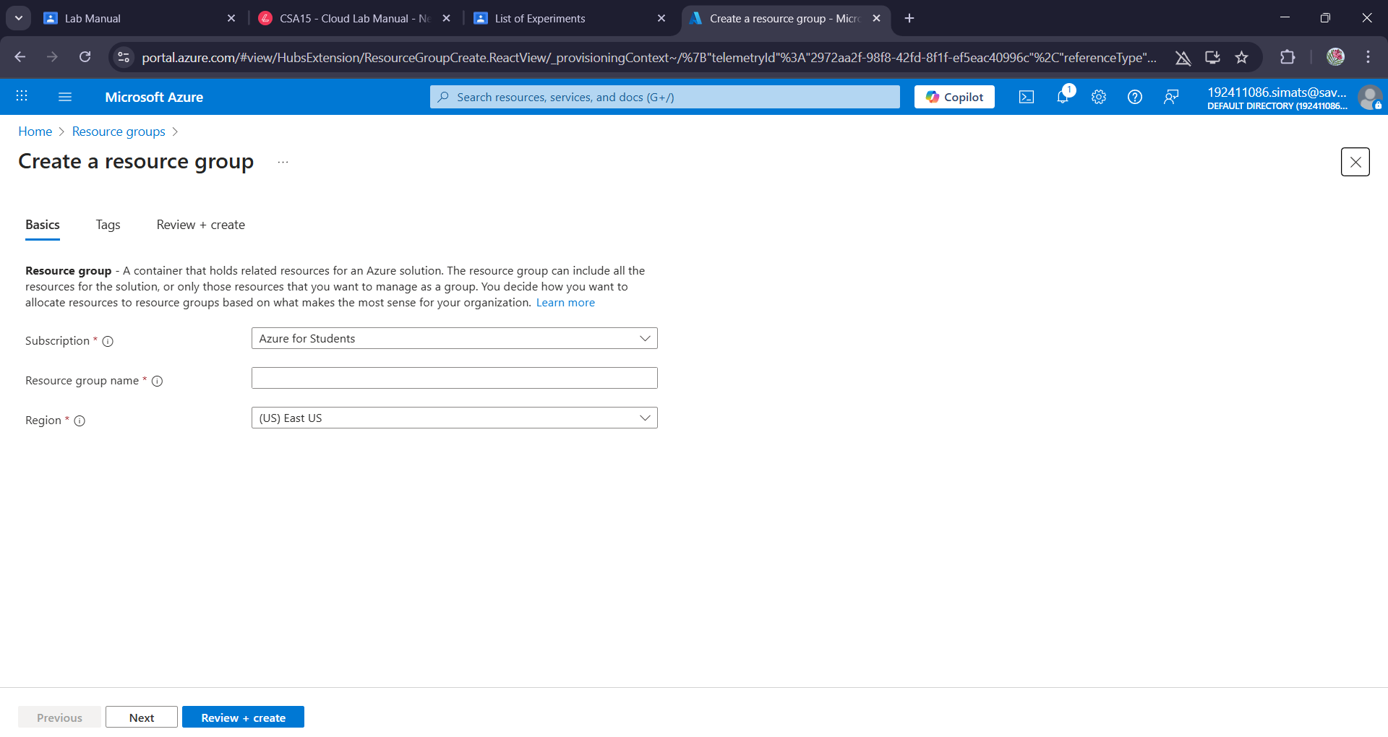

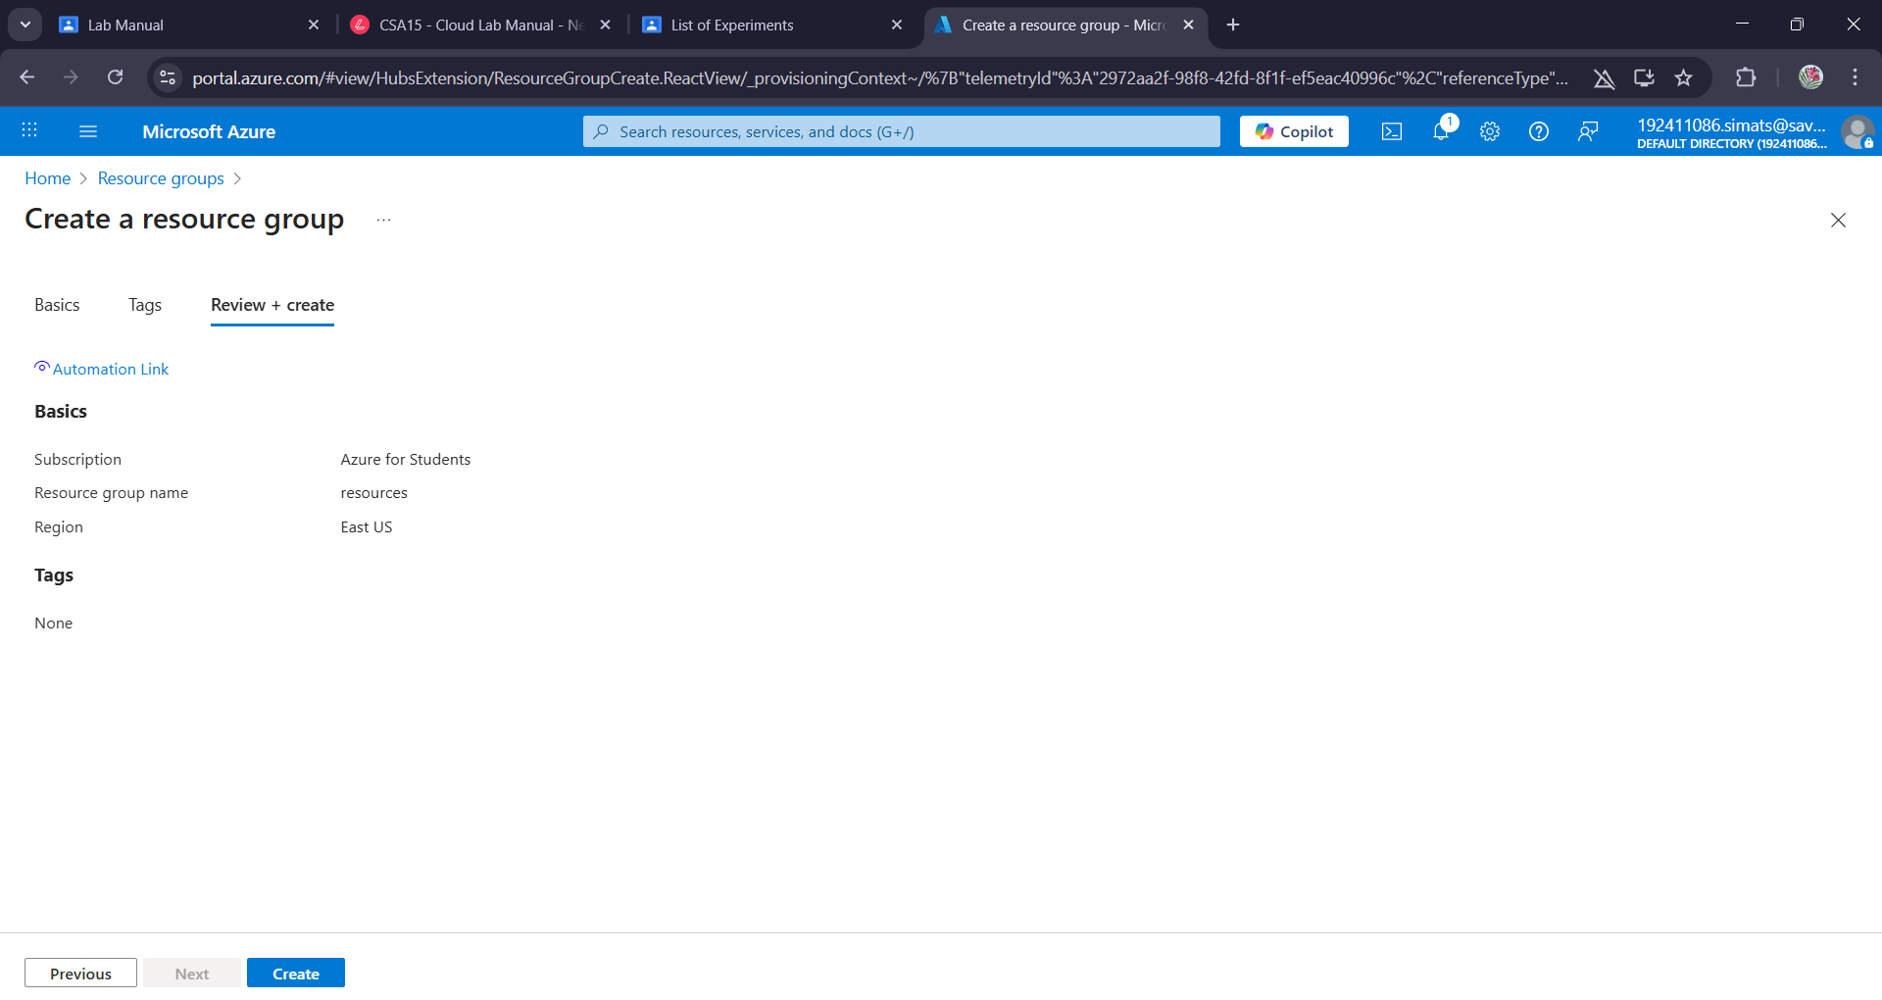

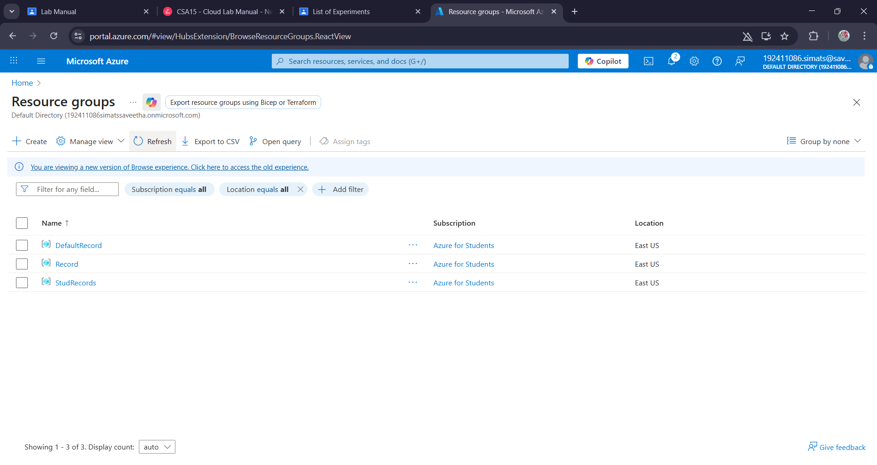

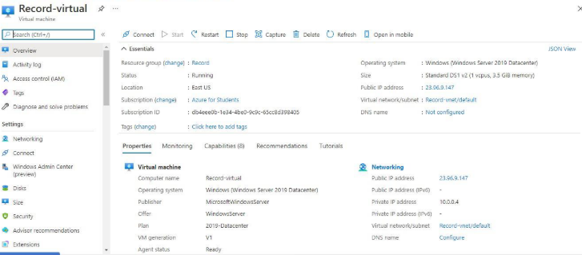

**Result:**

Infrastructure as a service(iaas) by creating a virtual machine using a public cloud

service provider(azure/gcp/aws) configure with minimum cpu,ram and storage and launch the vm

image has been demonstrated.